Case 6-Afr- Burkina Faso- Niger River Delta -Bura Terracotta Head-16th-17th century

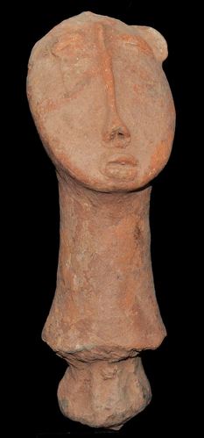

The **Bura culture** (**Bura system**) refers to a set of [archeological](https://en.wikipedia.org/wiki/Archeological) sites in the lower [Niger River](https://en.wikipedia.org/wiki/Niger_River) valley of [Niger](https://en.wikipedia.org/wiki/Niger) and [Burkina Faso](https://en.wikipedia.org/wiki/Burkina_Faso). More specifically, the [Iron-Age](https://en.wikipedia.org/wiki/Iron_age) [civilization](https://en.wikipedia.org/wiki/Civilization) exemplified by the Bura [culture](https://en.wikipedia.org/wiki/Culture) was centered in the southwest portion of modern-day Niger and in the southeast part of contemporary Burkina Faso (formerly known as [Upper Volta](https://en.wikipedia.org/wiki/Republic_of_Upper_Volta)). [[1]](https://en.wikipedia.org/wiki/Bura_culture#cite_note-whc.unesco.org-1)

[Iron industry](https://en.wikipedia.org/wiki/Iron_industry), in both [smelting](https://en.wikipedia.org/wiki/Smelting) and [forging](https://en.wikipedia.org/wiki/Forging) for tools and weapons, had developed in [Sub-Saharan Africa](https://en.wikipedia.org/wiki/Sub-Saharan_Africa) by 1200 BC.[[2]](https://en.wikipedia.org/wiki/Bura_culture#cite_note-2) The [first-millennium](https://en.wikipedia.org/wiki/First_millennium) **Bura-Asinda culture** in the [West African](https://en.wikipedia.org/wiki/West_Africa) [Sahel](https://en.wikipedia.org/wiki/Sahel) has been [radio-carbon dated](https://en.wikipedia.org/wiki/Radio_carbon_dating) as starting in the 3rd century AD and lasting until the 13th century. But very little is precisely understood about this "shadowy" and "mysterious" civilization and its culture because it was discovered only a few decades ago in 1975; and it was not until 1983 that the first [archeological excavation](https://en.wikipedia.org/wiki/Archaeological_excavation) was commenced. [[1]](https://en.wikipedia.org/wiki/Bura_culture#cite_note-whc.unesco.org-1)

Named for the [Bura archeological site](https://en.wikipedia.org/wiki/Bura_Archaeological_Site) near [Bura](https://en.wikipedia.org/w/index.php?title=Bura,_Niger&action=edit&redlink=1) in southwest Niger, the Bura culture produced a variety of distinctive [artifacts](https://en.wikipedia.org/wiki/Artifact_%28archaeology%29) made of [clay](https://en.wikipedia.org/wiki/Clay), [iron](https://en.wikipedia.org/wiki/Iron) and stone.[[3]](https://en.wikipedia.org/wiki/Bura_culture#cite_note-3)

However, it is not yet known how the entire Bura system linked up to other [ancient](https://en.wikipedia.org/wiki/Ancient) [African cultures](https://en.wikipedia.org/wiki/African_culture) and to such later [Islamic](https://en.wikipedia.org/wiki/Islam)-influenced [Sahelian kingdoms](https://en.wikipedia.org/wiki/Sahelian_kingdoms) as [Ghana](https://en.wikipedia.org/wiki/Kingdom_of_Ghana), [early Mali](https://en.wikipedia.org/wiki/Pre-Imperial_Mali), [later Mali](https://en.wikipedia.org/wiki/Mali_Empire), or [Songhai](https://en.wikipedia.org/wiki/Songhai_Empire). [[1]](https://en.wikipedia.org/wiki/Bura_culture#cite_note-whc.unesco.org-1)

**See also**

* [History of Africa](https://en.wikipedia.org/wiki/History_of_Africa) (emphasizes the pre-colonial civilizations)
  + [Ancient African history](https://en.wikipedia.org/wiki/Ancient_African_history) (emphasizes northeast Africa)
  + [History of West Africa](https://en.wikipedia.org/wiki/History_of_West_Africa) (a brief summary)
* [Nigerien culture](https://en.wikipedia.org/wiki/Nigerien_culture) -- that is, the contemporary [Culture of Niger](https://en.wikipedia.org/wiki/Culture_of_Niger)
* [Burkinabé culture](https://en.wikipedia.org/wiki/Burkinab%C3%A9_culture) -- that is, the contemporary [Culture of Burkina Faso](https://en.wikipedia.org/wiki/Culture_of_Burkina_Faso)

**References**

• [The Bura Archeological Site,](http://whc.unesco.org/en/tentativelists/5045/) [UNESCO](https://en.wikipedia.org/wiki/UNESCO) World Heritage Centre, translated into English

Bura belongs to a set of sites in this part of the middle valley of the Niger which cross the west of the Republic of Niger for 450 km; On a course 250 km long and about 150 km wide between the Malian border and the meanders of the "W".  
  
The site of Bura is located in a circle about 1 km in diameter open towards the south-east and dominated by control mounds of the continental terminal 10 to 20 m high.  
  
The site of the necropolis of Bura was fortuitously discovered in 1975 150 km northwest of Niamey. The excavated part is 25 m long from north to south and 20 m from east to west.  
  
Bura includes 3 types of sites that are not always easy to distinguish from each other:  
  
    ¨ Sites with necropolis proper characterized by a particular kind of coffin jars or anthropomorphic funerary urns made up of pottery surmounted by heads of statuettes, placed upside down on the ground and containing human skeletons in Asinda-sikka. These sites include 2 distinct archaeological levels.  
    ¨ Sites of religious altars and ritual ceremonies characterized by piles of large blocks of stone form a sort of flattened tumulus or esplanades such as Asinda-Sikka, Karey-Tondi, Jajé-Tondi or Mebera-Tondi . There are fragments of feet of tripod vases and fragments of pottery in the form of small painted cylinders.  
    ¨ Housing sites difficult to identify. But the discovery of fragments of tripod vases and sometimes of small piles and alignments of large blocks of stone testify to a human presence. Also on the site are quarrying wastes of quartzites or flint representing the site of arched framework and thin ceramic of Kosendo-gorizo ​​located to the west of necropolis, behind a hill.  
  
The general articulation of the system of occupation of space sites in Bura seems to revolve around two poles, the necropolis and the religious altar. The necropolis is almost always located in protected places.  
  
In the necropolis, anthropomorphic terracotta coffins or anthropomorphic funerary urns were laid upside down on the original floor and were then covered by a remobilization of the wind after the 13th century.  
  
The funerary urns are generally surmounted by heads of anthropoid statuettes presenting a generally anthropomorphic form. Thus we distinguish:  
  
    1. Longiform or tabular vases 70 to 80 cm high and 10 to 30 cm in diameter, surmounted either by complete statuettes of a person or mounted rider. These vases serve as supports for statuettes and sometimes form their bodies.  
    2. Hemispheric vases 20 to 40 cm high and 10 to 30 cm in diameter generally topped by statuette heads.  
    3. Semi-ovoid jars, approximately 50 to 70 cm in diameter and 40 to 60 cm in diameter, supporting either complete statuettes or statuette heads.  
  
Geological expertise reveals that the necropolis is based on the last remobilization of the erg former anterior to the 2nd or 3rd century AD and that it was covered during the relatively arid period that began after the 13th century. The period of use would thus be between the 3rd and the 13th century AD.  
  
Bura contains the oldest equestrian statuettes in terra cotta of the Niger basin.  
  
The statuettes and other objects of this site are the subject of an intense illicit traffic. The site is placed on the red list of I .C .O.M.  
  
Statements of authenticity and / or integrity  
  
The 625m² of the eponymous site was covered by a large metal farm that protects the entire site. On this surface, only 150m ² have been excavated to the level of the skeletons to 3m of depth.  
  
The first intention was to make a museum of the site, unfortunately a contest of circumstance did not make it possible to finalize this project.

• • Duncan E. Miller and N.J. Van Der Merwe, 'Early Metal Working in Sub Saharan Africa' *Journal of African History* 35 (1994) 1-36; Minze Stuiver and N.J. Van Der Merwe, 'Radiocarbon Chronology of the Iron Age in Sub-Saharan Africa' *Current Anthropology* 1968.

• Note the exhibits of Bura culture artifacts at the Hamill Gallery at [*"Archived copy"*](https://web.archive.org/web/20110807214209/http:/www.hamillgallery.com/BURA/)*. Archived from* [*the original*](http://www.hamillgallery.com/BURA) *on 2011-08-07. Retrieved 2009-10-16.* and the Barakat Gallery at [[1]](http://www.barakatgallery.com) 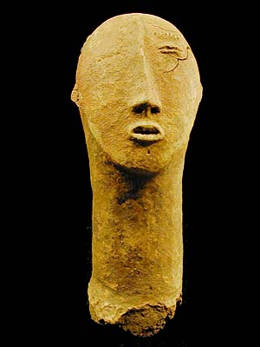 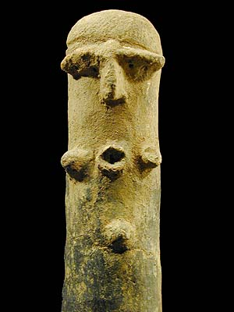

BURA, TERRACOTTA HEAD NO. 2, 11", $200, SOLD, Niger © Tim Hamill

Little is known of the Bura civilization (ca. 3rd - 11th centuries), first discovered in 1975, excavations began in 1983. Most of the archeological sites are in what is now Niger. Most of the objects dug up are terracotta heads or vessels. Many of these terracotta heads are fragments from vessels or figures. All are drilled and mounted on black iron bases.

